**KIKI’S KATERING DINNER OPTIONS**

**501 247-0263**

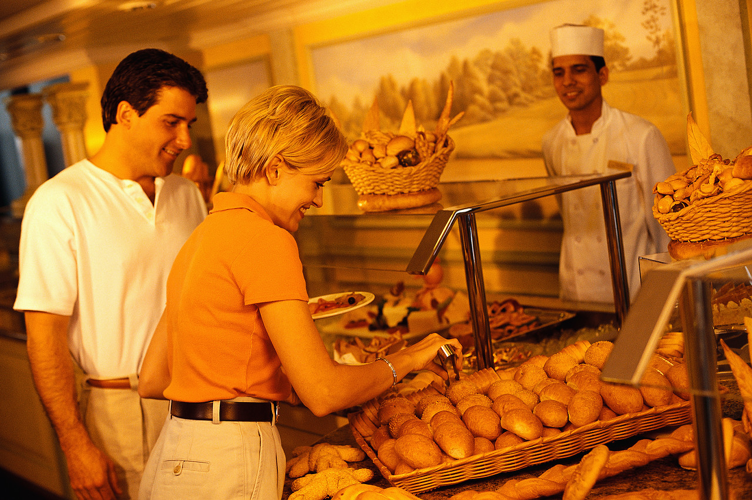

**EXAMPLE MENU (BUFFET STYLE)**

Choice of Protein

Beef, Poultry, Pork or Seafood

Vegetables:

- Green Beans - Cabbage

- Zucchini/Squash - Greens

- Corn - Mixed Vegetables

Starch:

Au Gratin Potatoes Candied Yams

Corn Bread Dressing Macaroni Salad

Mash Potatoes Macaroni -n- cheese

Wild Rice White Rice

The meal will include choice of meat, (prepared as desired), one starch, one vegetable, salad, rolls and choice of sweet/un-sweet tea or Kiki’s Signature Punch.

Prices are as follows with **food** only:

1 meat $12.50pp

2 meat $16.00pp

3 meat $20.00pp

Add starch/vegetable for an additional $1.50pp per item chosen

Add a Dessert to your meal:

* Cake - Cobbler - Bread Pudding
* Strawberry Shortcake

Inquire about additional options and pricing

Flatware: (china)- add $5.00pp Paper- add $2.50pp

# THIS IS JUST A BASIC PLAN FOR OPTIONS

WE CATER TO WHATEVER YOU WANT

